Project Design Phase
Solution Architecture

Date | 18 February 2026
Team ID | LTVIP2026TMIDS91707
Project Name | Flood_Prediction
Maximum Marks | 4 Marks

Solution Architecture:
The solution architecture of the flood_prediction system bridges the gap between the problem of late flood warnings and a technology-driven predictive solution. The architecture is designed to process user-provided weather parameters and generate accurate flood predictions using machine learning techniques.
The system follows a web-based client–server architecture where users interact with a simple web interface. The backend processes the inputs, applies a trained machine learning model, and returns the prediction result to the user.

Example - Solution Architecture Diagram:
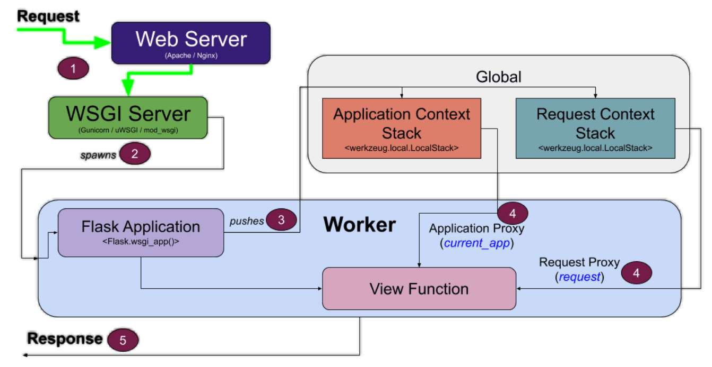
Figure 1: Architecture and data flow of the voice patient diary sample application
Reference: https://aws.amazon.com/blogs/industries/voice-applications-in-clinical-research-powered-by-ai-on-aws-part-1-architecture-and-design-considerations/

